Student Placement Workbook-

- Part of the ‘Work Inspiration’ Toolkit -

This workbook forms part of the ‘Work Inspiration Toolkit’. This is the main document that the student will keep with them and fill in at the end of each day. It helps them keep all the key details in one place.

The Work Inspiration website www.work.inspiration.com, has further free resources and case studies to support the development of your placement.

This template document has been designed in Word so you can tailor it to your businesses needs and format it into your corporate style. Please be aware that this is just guide and the Health and Safety aspects in particular must be carefully considered and edited to suit your business.

“I learnt about what Capgemini do and alternatives to university. And how businesses work in the real world.” - Student, Heathland School.

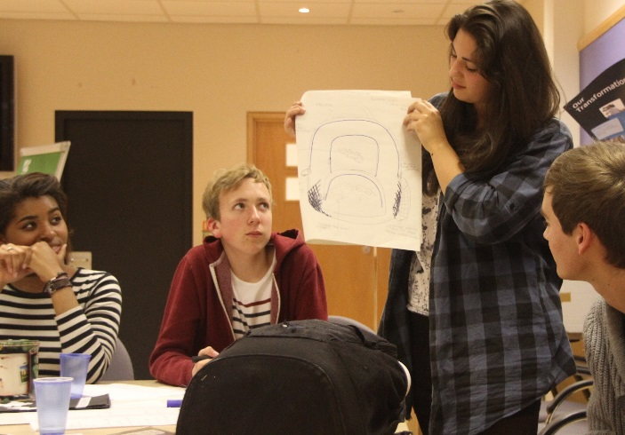

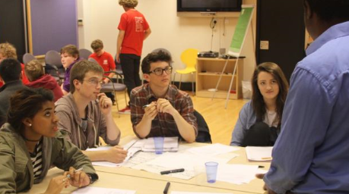
Contents
- Welcome message
- About us
- The ten Student commitments
- Your expectations and goals
- Key Contacts
- Template Confidentiality Agreement
- Induction and safety quiz
- My placement timetable
- Daily learning logs
- End of placement Supervisor/Buddy feedback form
- End of placement student feedback form
- Students perceptions of work experience questionnaire
- My Personal Action Plan
- Thank you message
- Certificates of Completion and Inspiration

- Welcome message
“Thank you for joining us at <<<Insert Name of Company>>> I remember my first day, I felt a little nervous and anxious but the team made me feel very welcome and I have loved working here ever since.

We have designed this programme with you in mind, to give you a real insight into what it’s like to work here. But it’s not just about you finding out about us, it’s about you finding out about yourself: what you’re good at and what your talents are. We really want you to get the most out of your time with us and achieve things during the placement that you will feel proud to tell your mates about.

So listen and learn from your colleagues and put your very best into it. Use your initiative and really show us what you’ve got.

Your ‘Work Inspiration’ journey is just about to start, Good Luck!”

<<<<Insert Chief Executive Signature>>>>
<<<<Insert company name>>>>

- About us
<<<<Insert some text here about what your business is about to help the student understand what you do, how you do it and who you do it for. Talk about the range of careers available in your industry>>>>>

- The ten Student commitments
The <<<<Insert company name>>>> Work Inspiration Programme has ten commitments that we want you to make so that you have a really inspiring placement.

Before my placement I will…
- Discuss with my school teacher the skills I hope to learn on my work placement

During my placement I will…
- Listen carefully to the induction and safety briefing and complete the quiz, so I can work safely during my placement
- Always behave in a courteous and professional manner
- Be punctual and notify my Supervisor/Buddy by 9.00am if I’m going to be late or absent for any reason
- Meet with my Supervisor/Buddy at the end of each day to discuss my progress and reflect on what I have learned that day
- Complete a project and present it back to the team
- Have fun!

After my placement I will…
- Discuss with my school what I learned and how the placement matched my expectations.
- Feedback my views on the placement
- Make a Personal Action Plan, to help me work towards my goals after my placement

- Your expectations and goals

Write down what you hope to get out of your placement? What skills to you hope to learn?

Write down your expectations; what do you think it will be like to work here?

- Key contacts

Key contacts during my placement
Name of Student (Capitals):
Signature:
Name Contact at School:
Contact at School Email:
Contact at School Phone:
Supervisor/Buddy Name:
Supervisor/Buddy Jobtitle:
Supervisor/Buddy Email:
Supervisor/Buddy Phone:
Dates of Placement:

Template Confidentiality Agreement

Work Experience

Confidential Information - Compliance Procedure

IMPORTANT - PLEASE READ CAREFULLY

As a professional company it is necessary and important that we protect both our clients and ourselves from unauthorised disclosure of confidential information.

It is also illegal for any person to use price sensitive information for financial gain or for the avoidance of any financial loss. It is also unlawful to pass the information to a third party.

It is therefore important to both <<<Insert Name of Company>>>>> and you to ensure confidential information is handled with care. If you have any doubt as to the status of information you should discuss it with a Supervisor/Buddy or a senior member of staff of the team you are working with who will advise you.

Declaration:
I have read the above and understand that I have a duty to handle confidential information carefully whilst I am assigned to <<<Insert Name of Company>>>>>. I understand that any failure to handle confidential information with due care and/ or any improper use or disclosure of price sensitive information is likely to result in my immediate removal from the Work Inspiration programme.

Student Name (Capitals)…………………………………………………………………

Signed:………………………………………………………………….…date:……………

Please immediately pass original to the <<<Insert name of Supervisor/Buddy >>> -

- Induction and safety quiz

Up to date HSE information for Work Experience placements can be found at www.hse.gov.uk

While you are working with us, you will be treated as a <<<Insert Name of Company>>> employee and this comes with certain responsibilities, one of them that we take very seriously is Safety. You must follow our codes of conduct while on your placement. Listen very carefully to the induction and safety briefing and answer the questions below so we know, you will be safe during your placement with us.

Induction and safety quiz :
Question: | Answer:
My Supervisor/Buddy’s name is…
My nearest fire exit is…
If my Supervisor/Buddy isn’t around I can contact….
The site contact number is…
The fire drills take place at…
The fire assembly point is….
If I have an accident, or see a safety hazard then I must report it to….
The exit is located….
The toilets are located….
I leave my coat and bag at…
If I am sick or late I have to contact .. | Who?:……………………………………...…. By what time?:……………..
The dress code is ….
Lunch/breaks will be spent in….
My hours of work are…
Length of breaks… | Morning?...............…..Afternoon?.......................Lunch?........................
Supervisor/Buddy declaration:
I have ensured that the student understood fully the induction and safety briefing.
Supervisor/Buddy Signature:

……………………………......
Supervisor/Buddy Name (Capitals): Date:

……………………………...... ………………………….
Student declaration:
I have understood the induction and safety briefing and agree to abide by the code of conduct.
Student Signature

……………………………......
Student Name (Capitals) Date:

……………………………....... ………………………….

- My placement time table
Use this timetable to make a note of things like tasks or who you’ll be meeting, when and where.

 | Who | Where | When
Day 1
Day 2
Day 3

Additional Notes:

9. Day 1 Learning Log

What did you do today?

What are you most proud of?

What did you learn about <<<Insert Name of Company>>>>>?

What did you learn about yourself?

What did you learn about how others work? What skills did they need to have to do their job?

How would you add what you have achieved today to your CV?

What do you need to prepare for tomorrow, so that it is even better than today?....

Day 2 Learning Log

What did you do today?

What are you most proud of?

What did you learn about <<<Insert Name of Company>>>>>?

What did you learn about yourself?

What did you learn about how others work? What skills did they need to have to do their job?

How would you add what you have achieved today to your CV?

What do you need to prepare for tomorrow, so that it is even better than today?....

Day 3 Learning Log

What did you do today?

What are you most proud of?

What did you learn about <<<Insert Name of Company>>>>>?

What did you learn about yourself?

What did you learn about how others work? What skills did they need to have to do their job?

How would you add what you have achieved today to your CV?

What do you need to prepare for tomorrow, so that it is even better than today?....

10. End of Placement Supervisor/Buddy Feedback Form
The student should take this form with them to help with future job applications.

Name:
Company / placement description:
Supervisor/Buddy:
Date of work placement:

Feedback

Workplace Skills | How the quality was demonstrated (circle where appropriate)
Attendance | Poor, no explanation | Some explained absence | Good – 90% | 100%
Time-keeping | Sometimes late | Usually on time | Always on time | Always Early
Attitude | Some interest, some tasks completed | Interested, tasks completed on time | Well motivated, conscientious | Always looking for more
Reliability | Reliable with supervision | Reliable with minimum supervision | Reliable and keen to take responsibility | Flexible, accurate responsible and uses initiative.
Communication | Some effort made | Good – communicated well when involved | Very good – initiated some conversations and asked if unsure | Excellent – communicated well and fitted in with the team
Confidence | Needed encouraging | Shy at first but improved during placement | Very good | Excellent – very confident from day one.

Particular strengths

Development needs

How did the Supervisor/Buddy find the experience?

Reference/ Summary of achievements | <<<Give the student a reference that they can use on their CV which sums up what they achieved: knowledge acquired and skills displayed>>>

11. End of Placement Student Feedback Form
Thank you for completing your work experience with. We would like you to reflect on your time at <<<Insert Name of Company>>> to understand how we could improve the programme
Your feedback helps us improve our placements for the next student
Which sessions did you find most interesting and why?
Which sessions did you find least interesting and why?
Did you feel that you met the aims you set yourself at the start of your work experience?
What task challenged you the most?
How was your relationship with your Supervisor/Buddy?
Was your time well managed? Did you have enough time for tasks, or too much?
Was there anything we missed? Perhaps something you would have liked us to cover?
Was there anything we could have done differently?
Would you choose to work here?
Yes ◻ No ◻
Would you like us to contact you in the future about apprenticeships/ or other opportunities?
Yes ◻ No ◻
Student Signature:

……………………………......
Student Name (Capitals): Date:

……………………………....... ………………………….

12. Students perceptions of work experience questionnaire

In this questionnaire we would like you to reflect on the impact the placement had on you.

Strongly Agree Disagree Strongly
agree disagree
I enjoyed my work experience ◻ ◻ ◻ ◻

I was satisfied with my work experience ◻ ◻ ◻ ◻

As a result of my work experience:
I better understand the skills employers
are looking for ◻ ◻ ◻ ◻

I know which personal qualities
employers think are important ◻ ◻ ◻ ◻

I have developed some new skills that
employers value (e.g. customer awareness,
and use of IT) ◻ ◻ ◻ ◻

I understand better why it is important
to do well at school ◻ ◻ ◻ ◻

I understand better how workplaces are
organised ◻ ◻ ◻ ◻

I am clearer about what I want to do in my
future education and career (post-16) ◻ ◻ ◻ ◻

This questionnaire is based on the Students perceptions of work experience survey: http://www.educationandemployers.org/research/research-reports/young-people/students-work-experience/

13. My Personal action plan
It takes planning to achieve your goals. Fill out your Personal Action Plan below and keep it in a safe place so you can refer to it in the months ahead, to make sure you are on track to achieving your goals.

This is the Personal Action Plan of …………….……………….………………
What are my goals for the future?
What do I need to think about to achieve these?
What will I need to do in school, to work towards these goals?
What are my actions for this month?
What are my actions for the next year?
Where do I want to be in five years’ time?
What college/university/traineeships/apprenticeships are going to help me to get there?
What is the first thing, that I need to do next to make things happen?
14. Thank you message
Here is some sample ‘thank-you’ text for you to edit to come from your most senior colleague.
“I wanted to say a really big thank you for all your hard work and commitment during our Work Inspiration placement. It isn’t easy to join a new organisation, so I hope you found working with us rewarding and inspiring and that we have given you valuable information to help you plan your career.

It’s been great to have you with us and I know my colleagues will have enjoyed working with you and showing you all the exciting career possibilities that <<<<Insert your industry here>>>> can offer.

Your Work Inspiration placement may have finished, but this isn’t the end of the journey

So I wish you the very best for the future,”

<<<<Insert Chief Executive Signature>>>>
<<<<Insert company name>>>>



15. Certificates of Completion and Inspiration

Work Inspiration Certificate of Completion

This Certificate acknowledges the
contribution and performance of:

<<<<Insert Student’s name>>>>
……………………………………………

For successfully completing the <<<Insert company name >>> Work Inspiration programme

..………………………………. ..……..…….
Supervisor/Buddy signature Dates

…………………..
<<<<Insert Chief Executive Signature>>>>
<<<<Insert company name>>>>

Certificate of Inspiration

This Certificate is awarded to:

<<<<Insert Colleagues name>>>>
……………………………………………

For really inspiring me during my <<<Insert company name >>> Work Inspiration programme

This award was nominated by:
<<<<Insert Student’s name>>>>

.….………………………………. …………………
Student’s signature Dates

…………………..
<<<<Insert Chief Executive Signature>>>>
<<<<Insert company name>>>>

